**Web Address:** www.connect.sakarya.edu.tr/meet

**Notice:** Adobe Flash Player driver on your computer should updated.

You should log in to the system as a Guest shown in Image 1.

You should use your **User Name** for the name box and your **Room Password** for room password box.

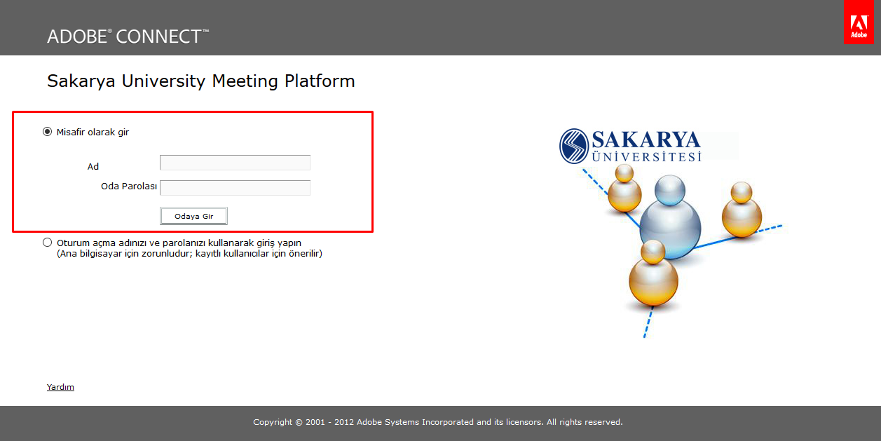

1. Adobe Connect Meeting Platform General View

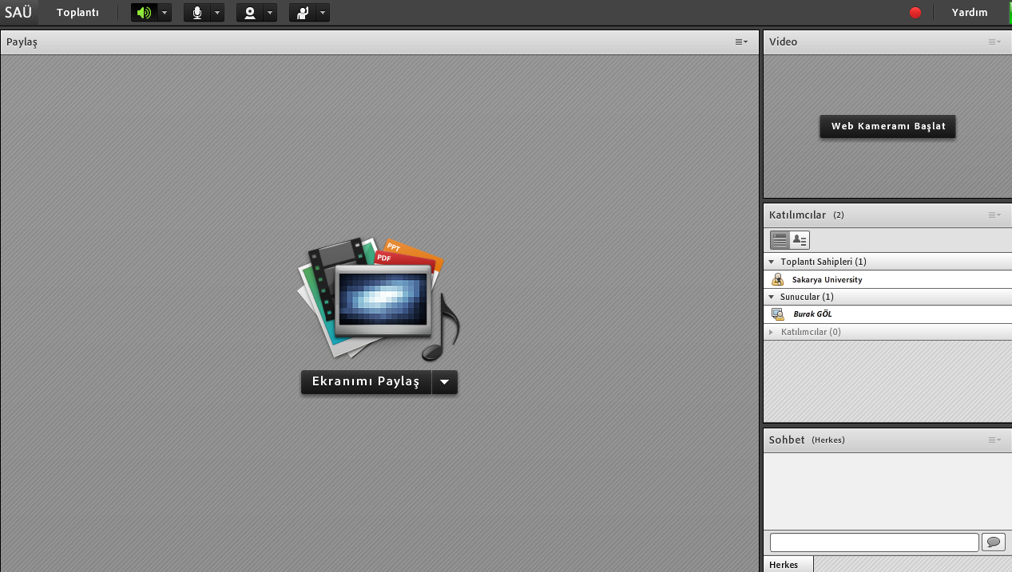

1. You should connect your microphone to the system as it is shown in Image 3 through microphone image (**Connect my Voice**). You should provide all of the permissions about your microphone.

After the microphone connection is established, you can find settings like lowering microphone volume, disconnecting etc.

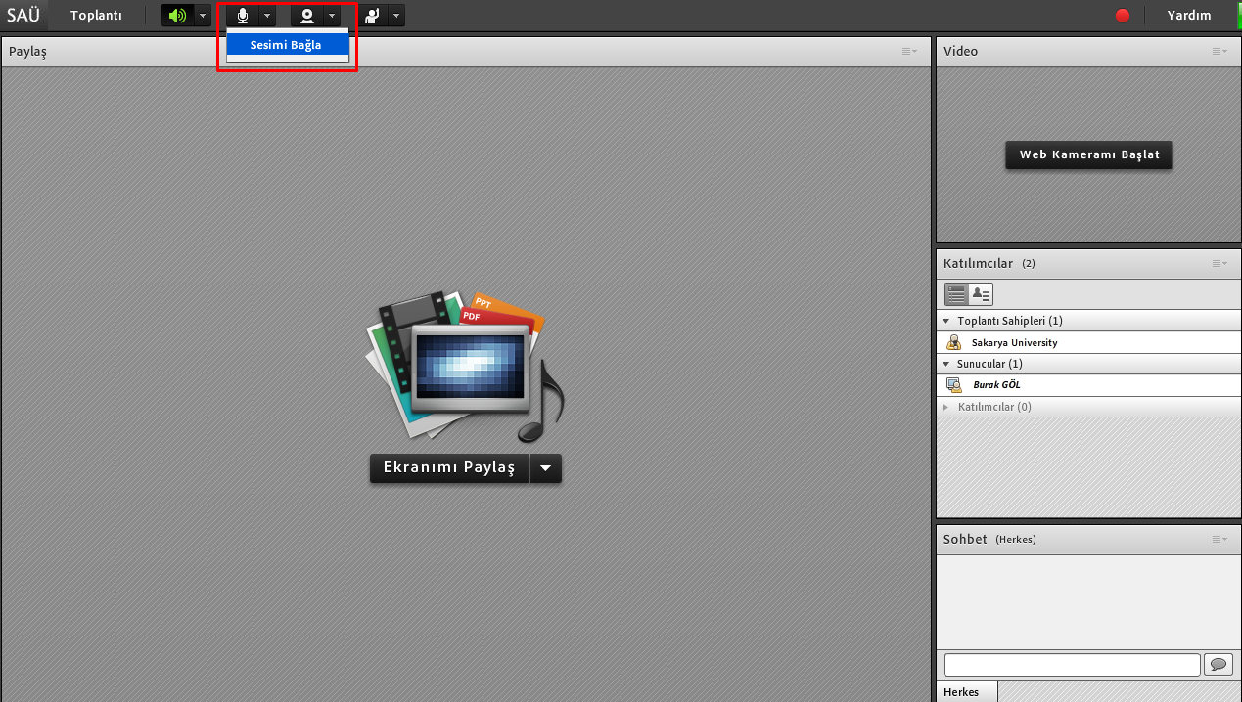

1. You should connect your camera to the system through camera image (**Start my Webcam**) as it is shown in image 4.

You should provide all of the permissions for your camera.

You should start camera sharing through **Start Sharing** button above your camera view.

